**Title of the manuscript**

Name Surnamea,*, Name Surnameb, Name Surnamec

aInstitution …

bInstitution …

cInstitution …

*Corresponding author’s email: [name.surname@abc.edu](mailto:name.surname@abc.edu)

*for Table of Contents use only*

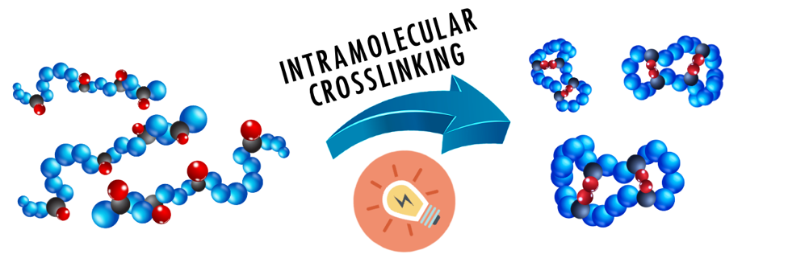

*(The figure should be a maximum size of 15 cm wide x 8 cm high) Please delete this caption at the time of submission!*

**A table of contents entry:**

Focus on the key findings of the manuscript and their importance. The text supplied should be 2-3 sentences long, using a maximum of 250 characters.